**INFO 2302 Web Technologies**

**API/JSON**

**FINAL ASSESSMENT ( Coding section)**

**Weather Web Application**

API can be a lot of fun and take your projects to a new level. In this Test, you need to develop a simple weather web application system with your own design. Your system must be used and integrate with the openweathermap.org API weather data. Before you proceed with the development, please read all the instructions below. (15 marks)

1. Get the API
2. Go to **openweathermap.org** at <https://openweathermap.org/>
3. Go to **Sign In** at the top-right menu bar
4. **Click “Create an Account”** to register your account for **FREE** as a diagram below

1. After sign up your account, please check your email to verify your email address
2. Do not need to register company.
3. Login back to **openweathermap.org** and click the **API keys** as shown in the diagram below:

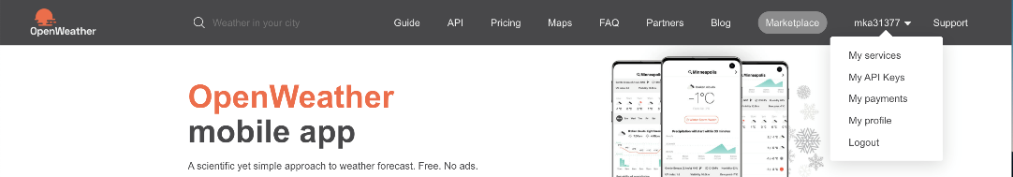

1. Copy the API keys and use it in your weather web apps.
2. System Requirement.
3. A picture containing graphical user interface

   Description automatically generatedLabel the **System Title** as <yourname> Weather Web Apps (e.g. Azmi Weather Web Apps)
4. Create **ONE**(1) input textbox

1. Create **ONE**(1) search button to find the country
2. Use this API link to fetch the weather data. [https://api.openweathermap.org/data/2.5/weather?q=<CityInputBox>&appid=<yourAPIKey>&units=metric](https://api.openweathermap.org/data/2.5/weather?q=%3cCityInputBox%3e&appid=%3cyourAPIKey%3e&units=metric)
3. The system will show the weather information (e.g. **city, country and temperature**) when the user key in the input box and click the **“Search”** button.

**END OF CODING ASSESSMENT**